
TSHS School Improvement Plan Summary

The Vision
100% Student Success
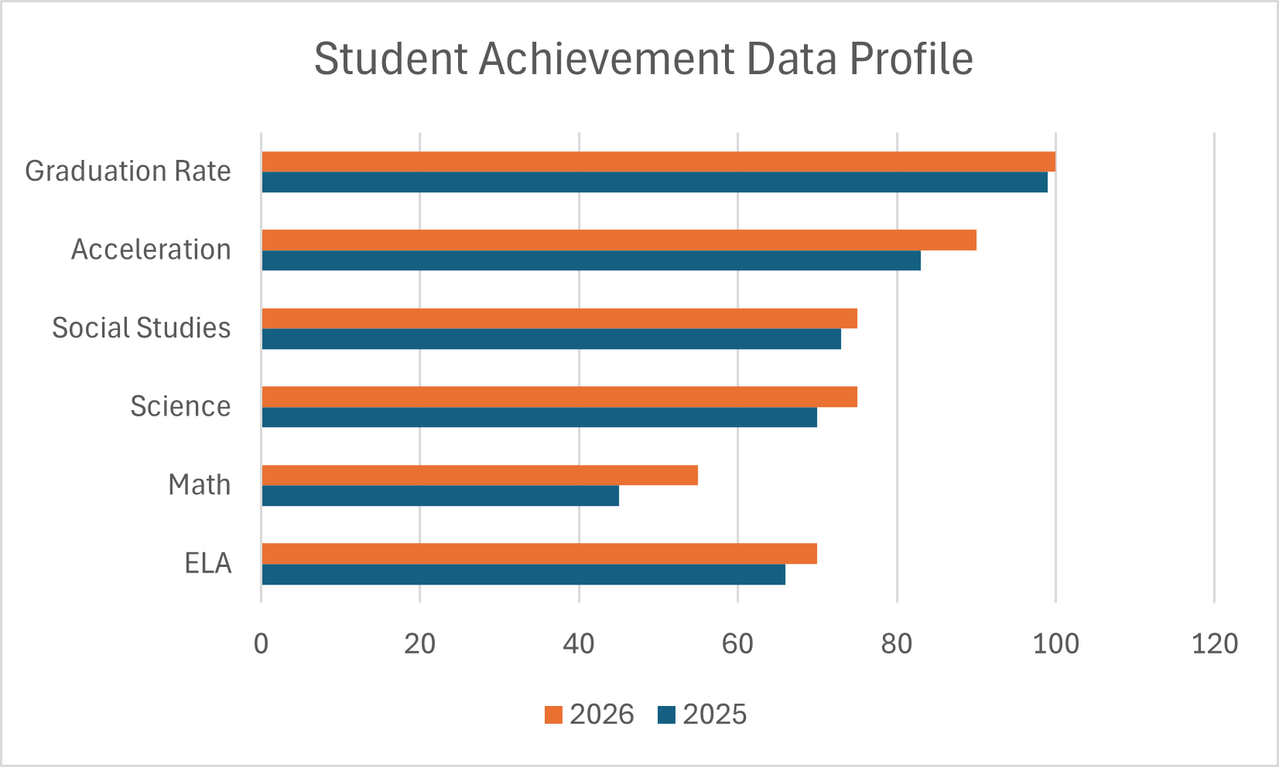
Instructional Priorities
- Use data analysis to help drive instruction
- Provide differentiated support and targeted instruction aligned to course benchmarks
- Foster positive student learning experiences
- Maintain positive behavior support and culture

Strategies for Success
- Implement collaborative structures and learning opportunities for all students
- Increase writing across all content areas
- Integrate robust vocabulary instruction in all core content areas
- Include opportunities for deeper learning and enrichment
- Celebrate and recognize student achievements and positive behaviors

